Biggar Light Horse Show & Gymkhana
June 29 & 30/24
Biggar Rodeo Grounds
Show starts 8:30am Saturday
Judge : Brett Jones, Saskatoon
Gymkhana starts 10:00 am Sunday
Heritage Circuit Show ( both days)

This show will run by the same rules & regulations of the Heritage Circuit handbook and the Equestrian Canada rules.
- Stallions may only be shown by adults.
- Any act of discourtesy or disobedience to the officials or contestants on the part of owner, groom, rider, driver, parent of rider, will result in entry disqualification.
- No tie downs, martingales and mechanical hackamores to be used, except in gymkhana.
- All foals to be tied or penned.
- No two people may use the same horse in the same class division.
- All protests must be made before horses leave the ring. Protest fee is first prize money in the class that the protest is being made. Protests must be in writing.
- No horses allowed in the bleacher area or at concession area.
- Proper dress code must be used at all times while showing. This includes, cowboy boots, long sleeved shirts, and hats/helmets.
- All Youth must wear ASTM or BSI approved helmets on the grounds during classes and practice time.
10.No refund of entry fees unless class is cancelled or vet approved. Classes may be combined depending on number of entries (ie Junior classes )
11. Competitors may only ride in their own age groups & Open classes.
12.Registration deadline is June 24th. Late entries are accepted with a late fee.
13.Show Office will be open 1 hour prior to show to pick up your numbers/ register.
14. The Biggar Rec Valley and Monarch Multiple Light Horse Project does not accept responsibility for loss, injury or damage to contestant, spectators, horses, or other property.
15. Heritage approved classes will count towards year end awards. Please ensure your SHF membership is current and that you have nominated if you are interested in accumulating points for the awards. To qualify for Heritage Provincial Finals September 22-24/24, you must have attended a minimum of 2 Heritage circuit shows and have placed in the Top 5 in a division to be eligible to participate in any class within that division.

Age groups: (as of Jan 1st/2024)
Junior C- 11 & under
Junior B-12-14
Junior A – 15 -17
Senior – 18 & over

Entry Fees:
Regular Classes- $8/class
Stake Classes- $20/class with a 80% payout.
Leadline & Walk trot- no entry fee!!
List of Classes
1st-$30, 2nd-$20, 3rd-$10, 4th-$5
- Yearling halter
- Two year old Halter
- 3 yrs & over Mares
- 3 yrs & over Geldings
- Junior C Showmanship*
- Junior B Showmanship*
- Junior A Showmanship*
- Senior Showmanship*
******10 minute break for lungeline warm up******
- Yearling Lungeline
- Two yr Old Lungeline
******10 minute English warm up******
- Junior English Pleasure*
- Senior English Pleasure*
- Junior Horse English Pleasure*
- Junior English Equitation*
- Senior English Equitation*
- Junior Road Hack*
- Senior Road Hack*
- Junior Show Hack*
- Senior Show Hack*
********Lunch Break*******
- Leadline (5 & under)
- Walk trot (8 & under)
- Junior Horse Western Pleasure*
- Junior C Western pleasure*
- Junior B Western Pleasure*
- Junior A Western pleasure*
- Senior Western pleasure*
- Open Western Pleasure STAKE $20 entry fee
- Ranch Rail*
- Junior C Horsemanship*
- Junior B Horsemanship*
- Junior A Horsemanship*
- Senior Horsemanship*
- Junior Western Riding*
- Senior Western Riding*
- Junior Reining*
- Senior Reining*
- Yearling in hand Trail
- Two yr old In Hand Trail
- Junior C Trail*
- Junior B Trail*
- Junior A Trail*
- Senior Trail*
- Ranch Trail*

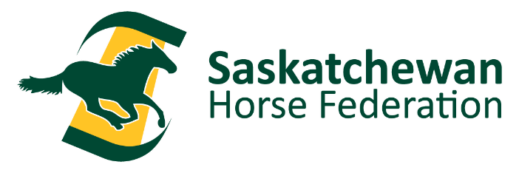
Sunday June 30th
Gymkhana
Start time 10:00
- Senior Egg Race
- Junior A Egg Race
- Junior B Egg Race
- Junior C Egg Race ( Junior C does not have to get back on horse)
- Senior Weiner Race
- Junior A Weiner Race
- Junior B Weiner Race
- Junior C Weiner Race ( don’t need to get back on)
- Senior Poles*
- Junior A Poles*
- Junior B Poles*
- Junior C Poles*
- Senior Quadrangle
- Junior A Quadrangle
- Junior B Quadrangle
- Junior C Quadrangle
- Senior Figure 8 Stake Race*
- Junior A Figure 8 Stake Race*
- Junior B Figure 8 Stake Race*
- Junior C Figure 8 Stake Race*
- Senior Barrels*
- Junior A Barrels*
- Junior B Barrels*
- Junior C Barrels*
- Senior Keyhole*
- Junior A Keyhole*
- Junior B Keyhole*
- Junior C Keyhole*
- Open Ride & Run
- Open 5$ Bill Race ( bareback – must supply own 5$ bill, no entry fee, winner takes the pot)

Heritage Classes are marked with a *

